Computer Network 1

LAB 1

Network Devices

Student Name: Alexandre Rousseau

Student ID: 1952001

1. Understanding functions of network devices
2. Network Interface Card (NIC)

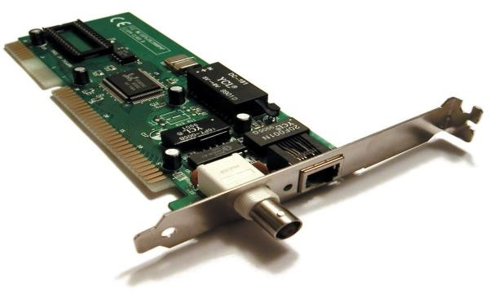

NIC function is to allow communication between computer system through local area network, and to make communications over large-scale network via Internet Protocol (IP).

Check NIC of a computer, what is its MAC address? 00-E0-4C-68-0E-9F

Cable to connect NIC to a network:

Type: RJ-45

Standard: Ethernet Cable

1. Hubs

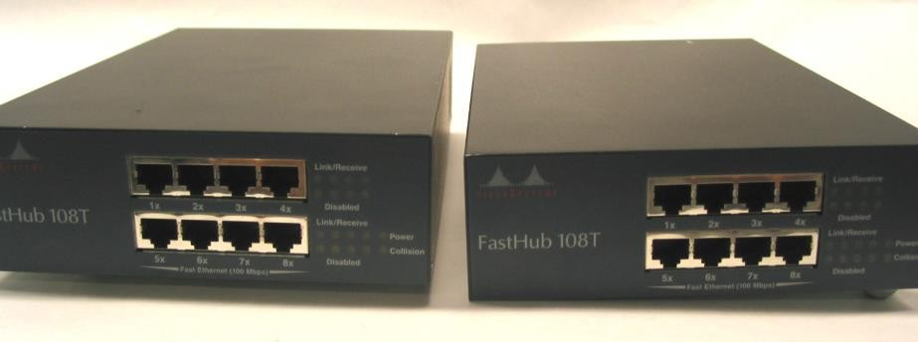

Roles of hub in a network: A hub is a networking device that allows you to connect multiple PCs to a single network. It is used to connect segments of a LAN.

Main characteristics:

* It works with broadcasting and shared bandwidth.
* It has 1 broadcast domain and 1 collision domain.
* Works at the physical layer of the OSI model
* A virtual LAN can’t be created using a hub
* Provides support for half-duplex transmission mode.
* A hub has just a single broadcast domain.
* Does not support spanning tree protocol.
* Packet collisions occur mostly inside a hub.

Weaknesses of hub:

* It’s mostly half-Duplex
* Does not offer dedicated bandwidth
* It cannot select Network’s Best Path
* There is no mechanism of any kind to reduce network traffic
* Possibility of device differentiation
* Network size

Hub ports: LAN Ports

1. Switches

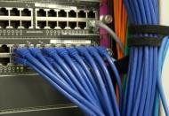

Roles of switches in a network: A network switch is a computer networking device that connects various devices together on a single computer network. It may also be used to route information in the form od electronic data sent over networks. Since the process of linking network segments is also called bridging, switches are usually referred to as bridging devices.

Main characteristics of switches:

* It is Datalink layer device
* It works with fixed bandwidth
* It maintains a MAC address table
* Allow you to a multi-port bridge
* Mostly comes work 24 to 48 ports
* Support half and full-duplex transmission modes

Differences between hubs and switches:

|  |  |
| --- | --- |
| Hubs | Switches |
| Physical layer | Data link layer |
| Perform frame flooding | Perform broadcast |
| Singular domain of collision is present in a hub | Varied ports have separate collision domains |
| Transmission mode is Half-duplex | Full duplex |
| Hubs operates as a layer 1 devices per the OSI model | Network switches help you to operate at layer 2 of the OSI model |
| To connect a network of personal computers should be joined through a central hub | Allow connecting multiple devices and ports |
| Uses electrical signal orbits | Uses frame & packet |
| Does not offer Spanning-tree | Multiple Spanning-Tree is possible |
| Collisions occur mostly in setups using hubs | No collision occurs in a full-duplex switch |
| Hub is a passive device | A switch is an active device |
| A network hub can’t store MAC addresses | Switches use CAM that can be accessed by ASIC |
| Not an intelligent device | Intelligent device |
| Its speed is up to 10 Mbps | 10/100 Mbps, 1Gbps, 10Gbps |
| Does not use software | Has software for administration |

Weaknesses of switches:

* Not as good as a rooter for limiting broadcasts
* Communication between VLAN’s requires inter VLAN rooting, but these days, there are many multilayer switches available in the market
* Handling multicast packet that requires quite a bit of configuration & proper designing
* Reduces the number of broadcasts domains

Switch ports: LAN ports

1. 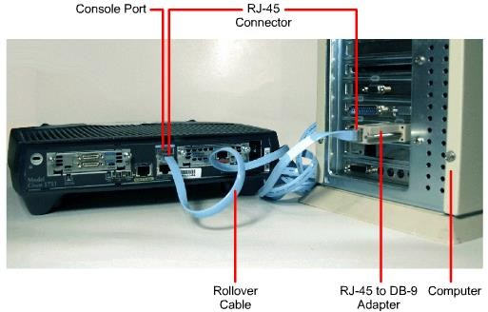Routers

Roles of rooter in a network: rooters are computer networking devices that serve two primary functions: create and maintain a local area network and manage the data entering and leaving the network as well as data moving inside of the network.

Main characteristics of rooters:

* It helps to share a network connection with multiple machines that increases productivity.
* A rooter allows delivering the packets of data in an organized way, which helps to lower the data load
* Rooter offers a steady reliable connection between network hosts
* Rooters make use of the alternative parts in case the main part fails to transfer data packets

Differences between routers and switches:

|  |  |
| --- | --- |
| Rooter | Switch |
| Rooters operate at layer 3 of the OSI model | Network switches operate at layer 2 of the OSI model |
| Rooter will offer NAT, NetFlow and QoS services | Switch will not offer such services |
| Store Ip address in the rooting table and maintain an address on its own | Store MAC address in a lookup table and maintain an address on its own |
| Networking device 2/4/8 ports | A switch is a multi-port bridge. 24/48 ports |
| Less duplex | In full duplex |
| The speed limit 1-10 Mbps for wireless and 100 Mbps for wired connection | The speed limit 10/100 Mpbs |
| Helps users to take the faster routing decision | Likely to take a more complicated routing decision |
| The router can perform NAT | Switches cannot |
| In various types of network environments, the rooter works faster | In a LAN environment, a switch is faster than Rooter |
| Rooter operations revolve around Ip addresses | Switches work with MAC addresses as it operates within the confines of a single network |
| Rooter can work within both wired and wireless network situation | Switches are restricted to wires network connections |

Router Ports: LAN ports

1. Access Points

Roles of access points: an access point is a wireless network device that acts as a portal for a devices to connect to a local area network.

Main characteristics:

* Root
* Root bridge
* Non root bridge
* Workgroup bridge
* Scanner
* Spectrum
* Repeater

Access point’s interfaces:

* Software status
* Hardware status
* Interface resets

Compare access point and other networking devices mentioned above: The router acts as a hub that sets up a local area network and manages all the devices and communication in it. An access point, on the other hand, is a sub-device within the local area network that provides another location for devices to connect from and enables more devices to be on the network.

Wireless routers can function as access points, but not all access points can work as routers. While routers manage local area networks, communicate with outside network systems, acquire, distribute, and dispatch data in multiple directions, establish a point of connectivity, and ensure security, access points typically only provide access to the router’s established network.

1. Modem

A modem (modulator-demodulator) is a device that modulates an analog signal to digital information. It also decodes carrier signals to demodulates the transmitted information.

The main aim of the modem is to produce a signal that can be transmitted easily and decoded to reproduce the digital data in its original form. Modems are also used for transmitting analog signals, from Light Emitting Diodes (LED) to radio.

**Dial-up Modem:** This type of modem is using the analog telephone line to connect two end devices like two personal computers. It offers an interface between the digital system and an analog system. It modulates the binary data into the carrier signal on the telephone line.

**DSL Modem:** DSL model uses twisted pair cable for transmission of signals. It will radiate at higher frequencies and covered more distance than the dial-up modems. It offers to speed up to 2 Mbps and even more, which depends upon the type and configuration.

**Cable Modem:** This type of modem is designed in a way to carry radio and television signals. It can be configured internally/ externally with the television line to convert the signals into the compatible mode.

Function to be performed at the transmitting end:

* Convert the data (0s and 1 s) into an appropriate analog signal.
* Perform the line control and signaling to other ends of a phone line.
* Send the dialing signal if the modem is designed to dial without the presence of a user.
* Offer protection against line overload and other problems.

Function to be performed at the receiving end:

* Receiving the analog signal and demodulate them
* Put the demodulate into RS-232 format connect to RS-232 interface.
* Perform line signaling and control.
* Have protection against the overload problem.

Here, are pros/advantage of Modem:

* More useful in connecting LAN with the Internet
* Speed depends on the cost
* The modem is the most widely used data communication roadway.

Here, are some drawbacks/cons of Modem:

* Slow speed when compared to the hub.
* Acts as an interface between LAN and Internet. It does not offer any traffic maintenance.
* Main drawback of a modem is speed. If you spend more money, you get more speed.